MULTIPLICATION UP TO 10
KS1 – 2007 Paper 1
1.
KS1 – 2009 Paper 1
2.
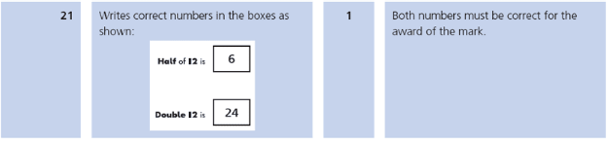
KS1 – 2016 Paper - Arithmetic
3.
4.
KS1 – 2016 Paper - Reasoning
5.
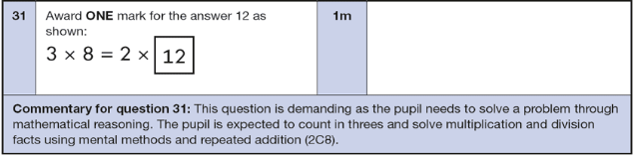
KS1 – 2016 Paper - Arithmetic (Second)
6.
KS1 – 2018 Paper – Arithmetic
7.

